1. What MuleSoft API-led connectivity layer is intended to expose part of a backend database without business logic?

1. Experience
2. Data
3. System
4. Process
5. Security

2. A web client submits a GET request to a Mule application to the endpoint /customers?id=48493.

Where is the id stored in the Mule event by the HTTP Listener?

1. Inbound Properties
2. Variables
3. Attributes
4. Payload

3. What is the purpose of the api:router element in APIkit?

1. Creates native connectors using a 3rd party Java library
2. Serves as an API implementation
3. Validates requests against RAML API specifications and routes them to API implementations
4. Validates responses returned from API requests and routes them back to the caller

4. What is the minimum required configuration in a flow for a Mule application to compile?

1. An event processor
2. An event source
3. A Logger component
4. A project RAML file

5. What is NOT part of a Mule 4 event?

1. message
2. payload
3. inboundProperties
4. attributes

6. What happens to the attributes of a Mule event in a flow after an outbound HTTP Request is made?

1. New attributes may be added from the HTTP response headers, but no headers are ever removed
2. Previous attributes are passed unchanged
3. Attributes do not change
4. Attributes are replaced with new attributes from the HTTP Request response (which might be null)

7. A Set Variable component saves the current payload to a variable with the name: images. What is the DataWeave expression to access the images variable?

1. #[payload.images]
2. #[images]
3. #[flowVars.images]
4. #[vars.images]

8. A web service implements an API to handle requests to http://acme.com/customers/{state}. A web client makes a request to this API implementation at http://acme.com/customers/CA.

What is the correct DataWeave expression to retrieve the value CA?

1. #[message.payload.inboundProperties.'http.uri.params'.state]
2. #[attributes.uriParams.state]
3. #[attributes.'http.uri.params'.state]
4. #[message.inboundProperties.'http.uri.params'.state]
5. #[state]

9. A flow contains an HTTP Listener as the event source. What is the DataWeave expression to log the Content-Type header using a Logger component?

1. #["Content-Type: " ++ attributes.headers.'content-type']
2. #["Content-Type: " + headers.'content-type']
3. #["Content-Type: " + attributes.headers.'content-type']
4. #["Content-Type: " ++ headers.'content-type']

10. A Mule application has two flows named parentFlow and childFlow. The childFlow begins with an HTTP Listener. A variable is defined in parentFlow, then an HTTP Request is made to childFlow's HTTP Listener with some headers set.

What is the scope of the variable and attributes in the parentFlow after childFlow returns a response?

1. The variable is accessible. All the attributes passed to childFlow are removed or replaced.
2. The variable is NOT accessible. All the attributes passed to childFlow are removed or replaced.
3. The variable is NOT accessible. All the attributes passed to childFlow are preserved.
4. The variable is accessible. All the attributes passed to childFlow are preserved.

11. A Mule application has a flow named parentFlow.

The parentFlow contains an HTTP Request operation at the end of the flow. The parentFlow also contains a Set Variable operation right before the HTTP Request operation.

What is the scope of the variable to the server receiving the HTTP Request from parentFlow?

1. The variable is accessible in the server but is immutable
2. The variable is accessible in the server, can be changed, and changes are seen back in parentFlow
3. The variable is NOT accessible in the server
4. The variable is accessible in the server, can be changed, but changes are NOT seen back in parentFlow

12. A Mule application has two flows named parentFlow and childFlow. A variable is defined in parentFlow.

What is the scope of the variable when the parentFlow calls childFlow using a Flow Reference?

1. The variable is accessible in childFlow but is immutable
2. The variable is accessible in childFlow, can be changed, and changes are seen back in parentFlow
3. The variable is NOT accessible in childFlow
4. The variable is accessible in childFlow, can be changed, but changes are NOT seen back in parentFlow

13. In what file does the Mule project keep track of all of its dependencies?

1. mule-artifact.json
2. pom.xml
3. mule-app.properties
4. Global.xml

14. How are multiple conditions used in a Choice router to route events?

1. To find the FIRST true condition, then route the same event to the matched route and ALL FOLLOWING routes
2. To route the same event to the matched route of EVERY true condition
3. To find the FIRST true condition, then distribute the event to the ONE matched route
4. To filter and aggregate the responses after copying the event to EVERY route

15. A Scatter-Gather processes three separate HTTP requests. Each request returns a Mule event with a JSON payload.

What is the final output of the Scatter-Gather?

1. An Object containing all three Mule event Objects
2. An Array of the three JSON payload Objects
3. An Array of the three Mule event Objects
4. An Object containing all three JSON payload Objects
5. The last JSON payload Object
6. The last Mule event object

16. An event contains a payload that is an Array of Objects. How is the event routed in a Scatter-Gather?

1. The ENTIRE event is sent to each route and processed SEQUENTIALLY
2. The event is SPLIT and different SMALLER events are routed and processed in PARALLEL
3. The event is SPLIT and different SMALLER events are routed and processed SEQUENTIALLY
4. The ENTIRE event is sent to each route and processed in PARALLEL

17. Refer to the exhibits. What happens to this flow when the Validation module's Is not null operator throws an error?

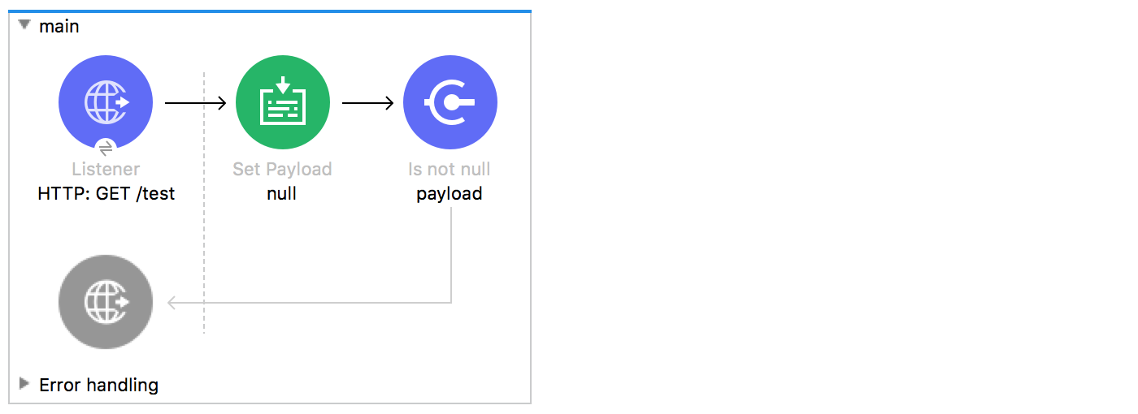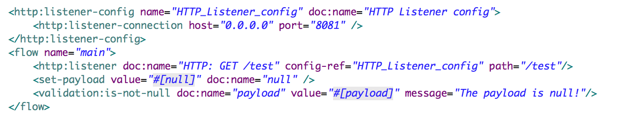

1. The flow silently stops processing its Mule event
2. The flow stops processing its Mule event and returns an error message to the HTTP Listener operation
3. The flow logs the error message in the console and continues processing its Mule event
4. The flow continues processing its Mule event and appends the error message to the end of the payload

18. Refer to the exhibits. The main flow has an On Error Continue scope. In the Configuration global element, default error handler is set to globalErrorHandler.

A web client makes an HTTP GET request to the flow's HTTP Listener. The Is number validator then throws an error with message "Validate - Payload is an Integer". What response message is returned to the web client?

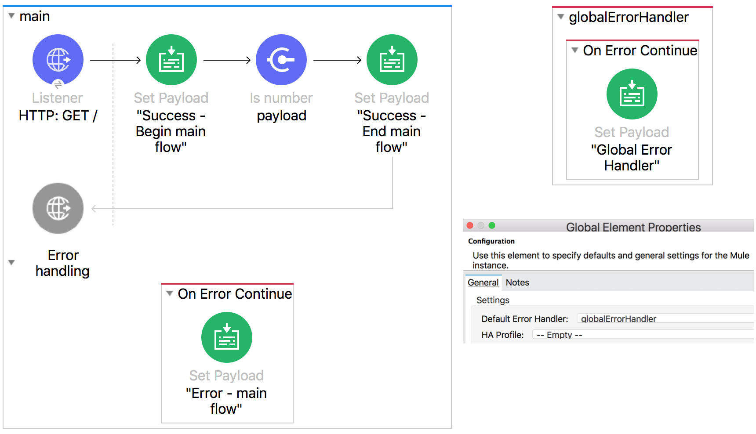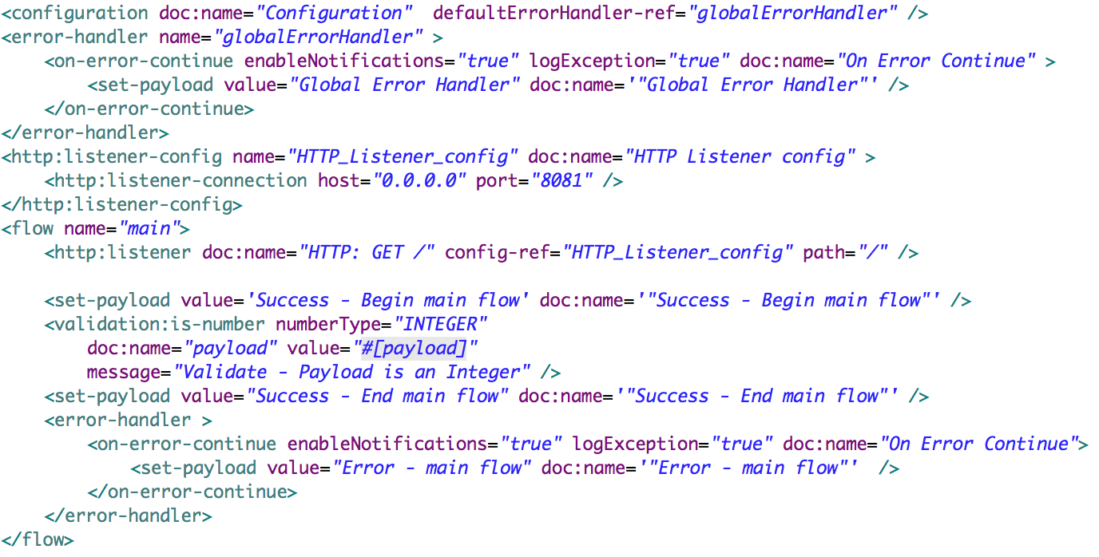

1. Error - main flow
2. Success - Begin main flow
3. Success - End main flow
4. Validate - Payload is an Integer
5. Global Error Handler

19. Refer to the exhibits. The main flow has an On Error Propagate scope. In the Configuration global element, default error handler is set to globalErrorHandler.

A web client makes an HTTP GET request to the flow's HTTP Listener. The Is number validator then throws an error with message "Validate - Payload is an Integer".

What response message is returned to the web client?

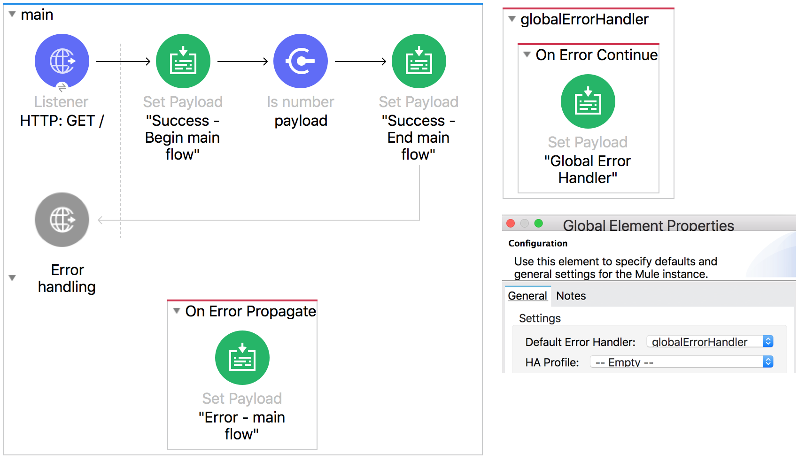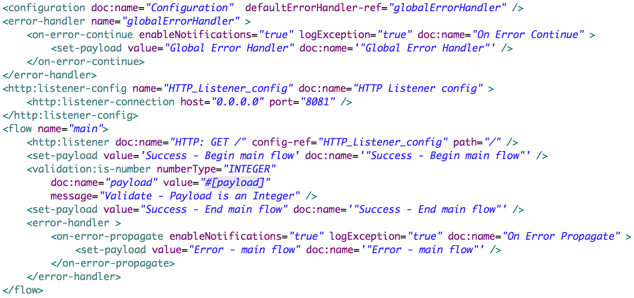

1. Error - main flow
2. Success - Begin main flow
3. Success - End main flow
4. Validate - Payload is an Integer
5. Global Error Handler

**20**. Refer to the exhibits. The private flow has an On Error Propagate scope. In the Configuration global element, default error handler is set to globalErrorHandler.

A web client makes an HTTP GET request to the flow's HTTP Listener. The Is number validator in the private flow then throws an error with message "Validate - Payload is an Integer".

What response message is returned to the web client?

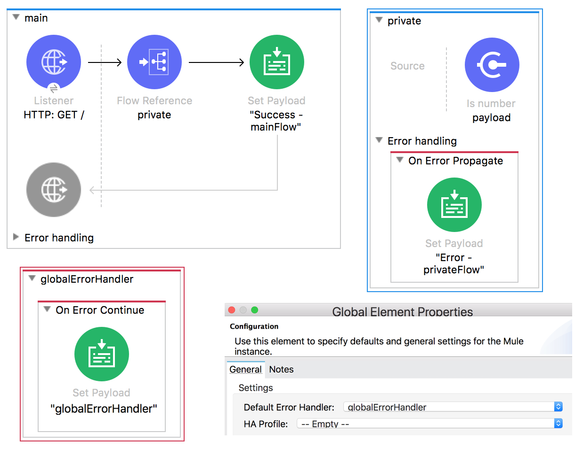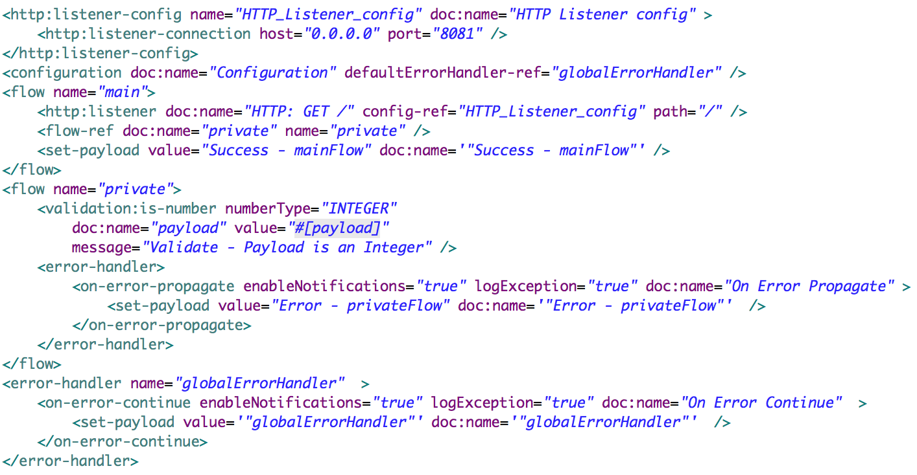

1. globalErrorHandler
2. Success - mainFlow
3. Error - privateFlow
4. Validate - Payload is a Number

**21**. Refer to the exhibits. The main flow has an On Error Continue scope and the private flow has an On Error Propagate scope.

A web client makes an HTTP GET request to the HTTP Listener. The Is number validator in the private flow then throws an error with message "Validate - Payload is an Integer".

What response message is returned to the web client?

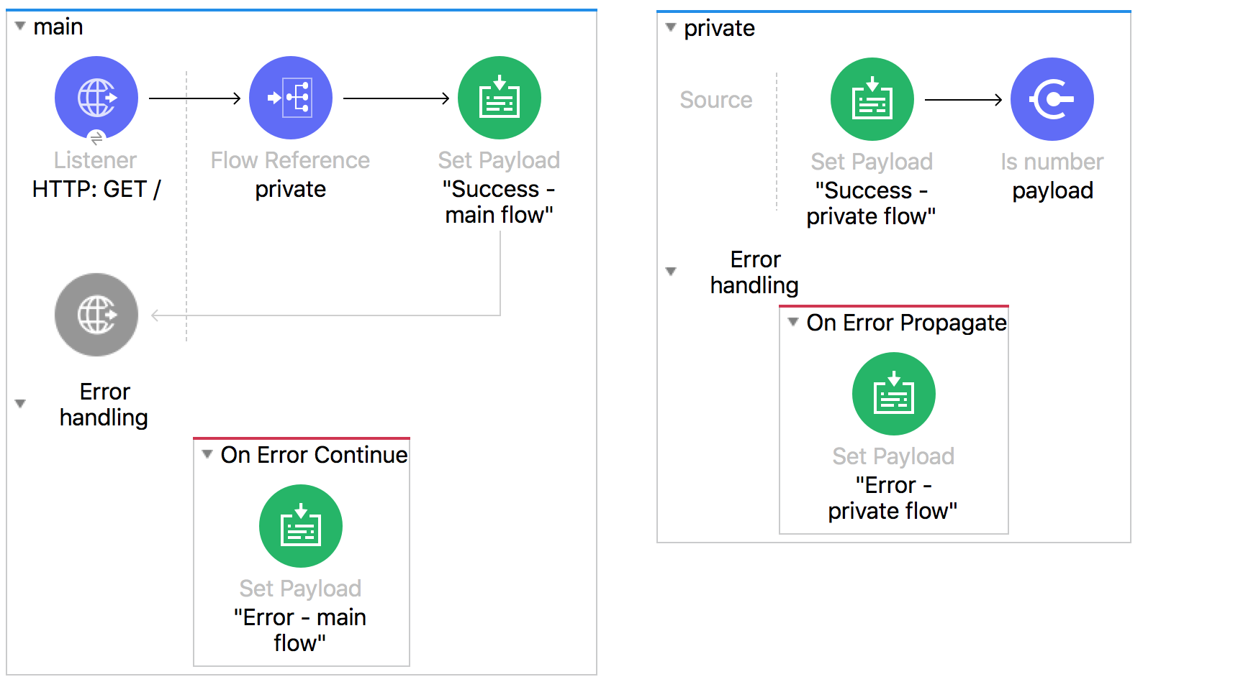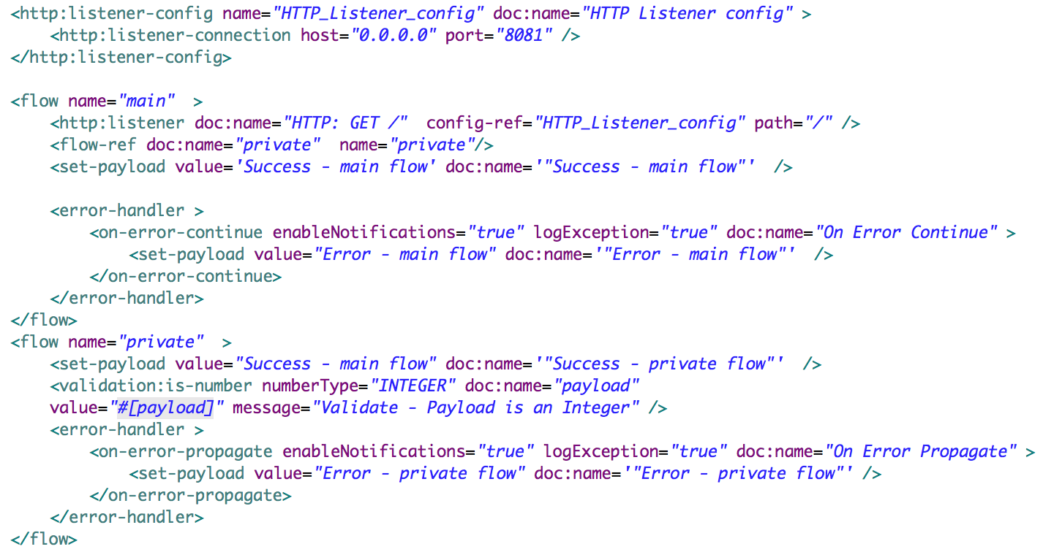

1. Success - main flow
2. Error - private flow
3. Success - private flow
4. Validate - Payload is Integer
5. Error - main flow

**22**.What DataWeave 2.0 type can be used as input to a map operation?

1. Object
2. Map
3. String
4. Key
5. Array

**23**. Refer to the exhibit. What are the values of the counter and stepVar variables after the Batch Job?

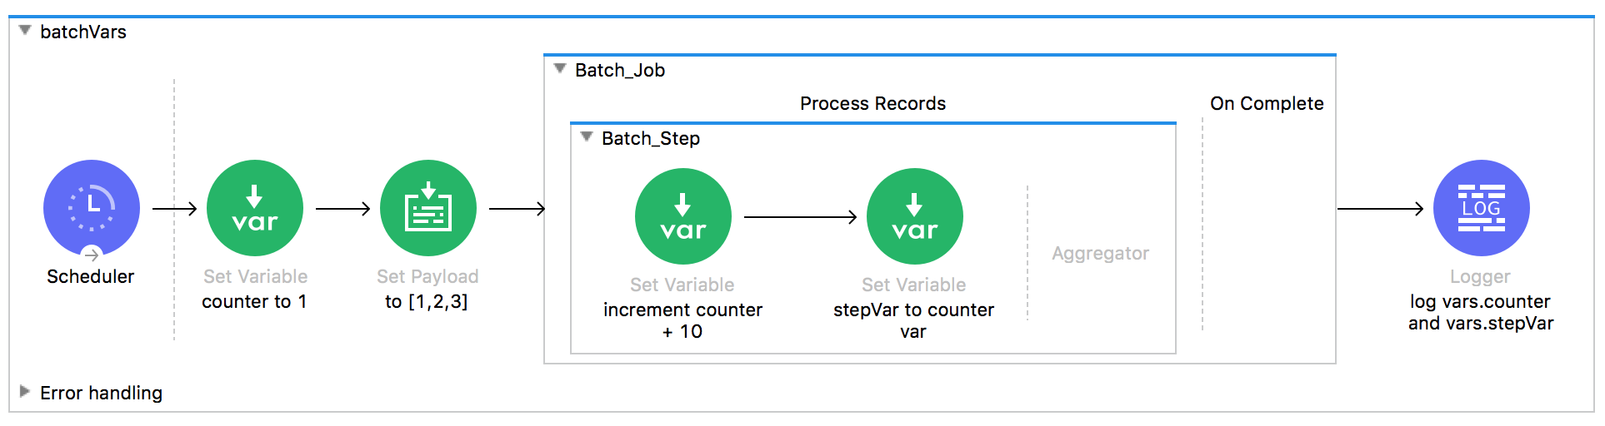

1. counter: 31, stepVar: 31
2. counter: 1, stepVar: 31
3. counter: 1, stepVar: null
4. counter: 31, stepVar: null

**24**. Refer to the exhibits. The Set Payload component sets the payload to a Map object (not an Array). The File Write operation writes out files based on this Map object. How many files are written to the file system when the flow executes?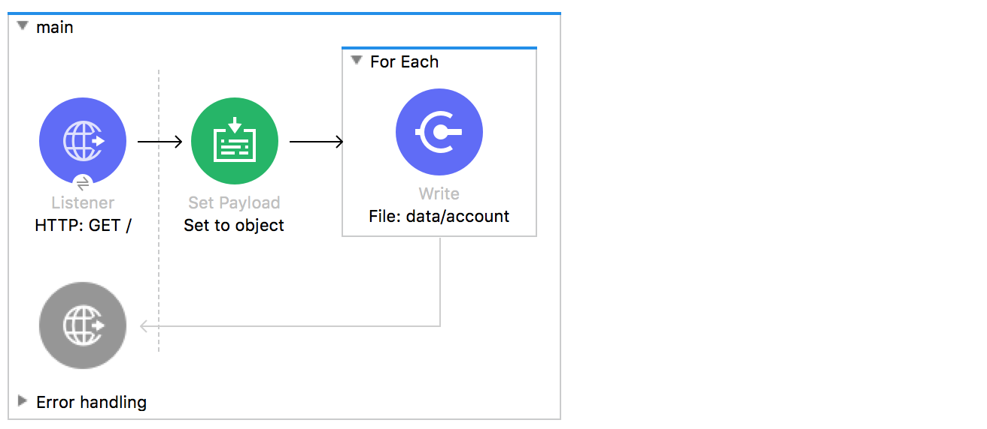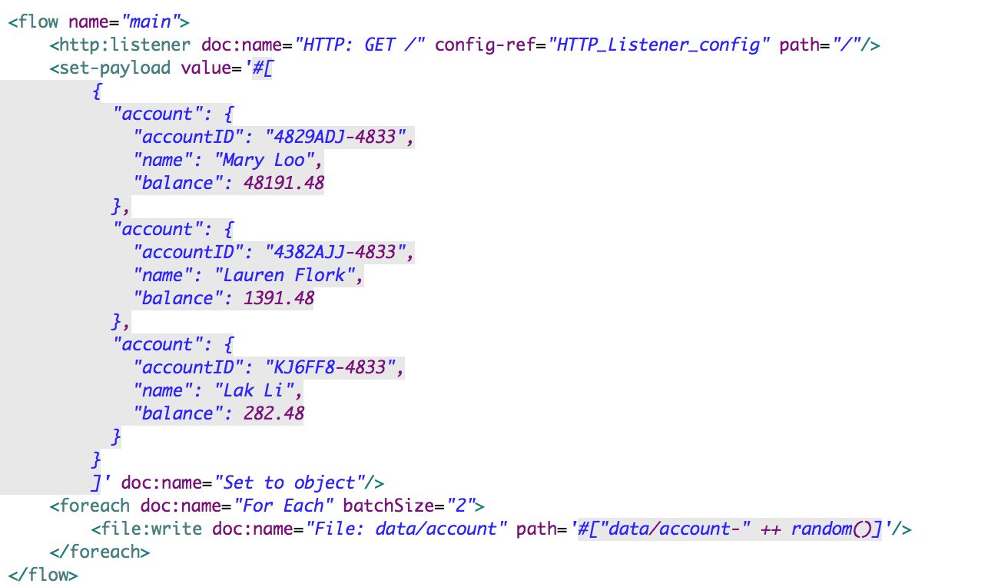

1. 0
2. 1
3. 2
4. 3

**25**. Refer to the exhibit. The payload [1,2,3] is passed to the Batch Job scope. In Batch_Step_1, a variable named batchStepPayload is set to the current payload.

What is the value of the last log message after one batch job completes?

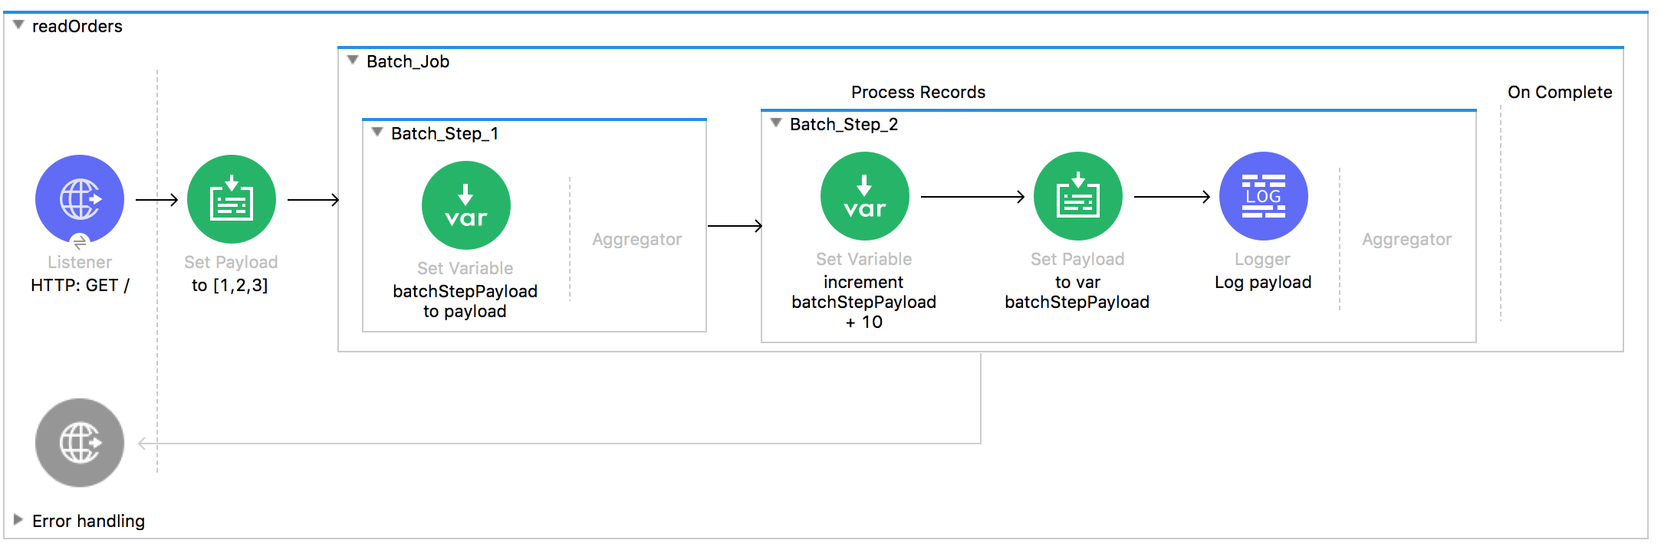

1. [11,12,13]
2. 13
3. 33
4. 30
5. 10